**Ganpat University**

**Faculty of Engineering & Technology**

**Computer Science & Engineerin0067**

***Name:- Dwij Vatsal Desai***

***Sem:- 2***

***Sub: - BOSS***

***Enrollment No.:- 23162121027***

***Prac:- 14***

**Practical 14**

Write shell script to manage(add/view/update) Marks database with following fields:

RollNumber,StudentName,LA,BOSS,BCS

1. List all the details of all students.
2. Add a new student with following details:

RollNumber: last 4 digits of your roll number

StudentName: yourname

LA: Marks in LA subject

BOSS: Marks in BOSS subject

BCS: Marks in BCS subject

1. Update all 70 marks to a new value 81.

***Image:-*** 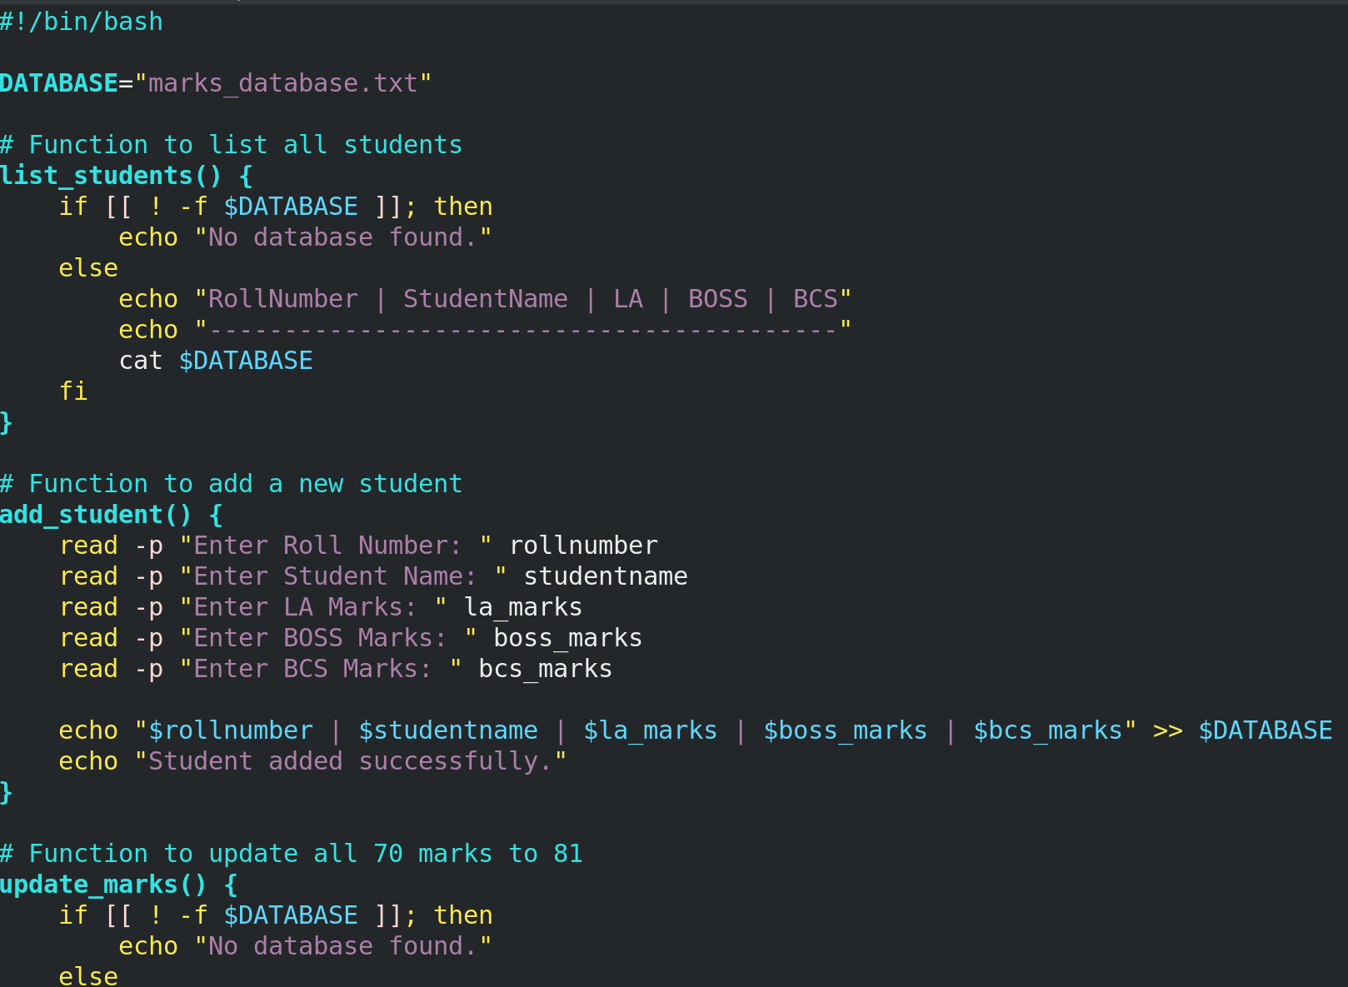 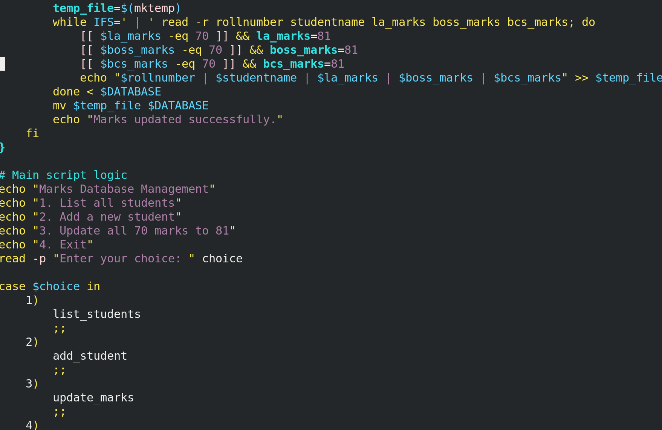 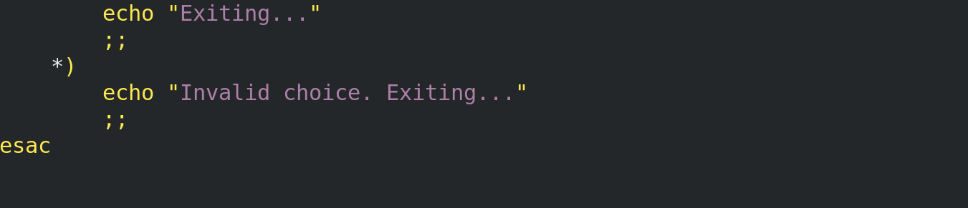

**Output:-**